**Copyright:**

Version1: (2022.03.22) at Kavli Institute, Trondheim, NTNU

The MINI2P distortion detection and correction method is from the paper Zong, et.al,Cell,2022

The MINI2P distortion detection GUI was written by Weijian Zong in the Moser lab

The SI device of MINI2P was modified from standard device in SI by Weijian Zong in the Moser lab, Mitchell Sandoe and Jacob Franklin in Vidrio Technologies, LLC

Updated version of this device and the user manual can be found in https://github.com/kavli-ntnu/MINI2P_toolbox

----------------------------------------------------------------------------

Copyright (C) 2021 Vidrio Technologies, LLC

ScanImage (R) 2021 is a software to be used under the purchased terms

Code may be modified, but not redistributed without the permission of Vidrio Technologies, LLC

**Dependency:**

1 Matlab: 2019b or later;

2 ScanImage: basic or Premium, 2021 or later;

3: Matlab toolbox “ Image Processing toolbox” : before installing “MINI2P”, please check inf image processing toolbox is installed. The method to check is shown below:

*This figure shows where you can find the Imaging Processing toolbox in Matlab.*

**Installation:**

1. Copy the entire folder “plugin” to SI root folder.

2. Copy the entire folder “+mini2p” to SI folder\+dabs\;

3. Copy file “MINI2PPage.m” to SI folder\+dabs\+resources\+configuration\+resourcePages\;

4. Copy file “MINI2PWidget.m” to SI folder\+dabs\+resources\+widget\+widgets\;

5.When starting ScanImage from Matlab, go to Machine Data File Editor, select “Devices”, press “+”, and select “Miscellaneous” 🡪 “MINI2P”. Then give a name to this device, i.e. “MINI2P tools”.

Note. Before installing the MINI2P, please make sure there is only one version of ScanImage installed.

6 When the MINI2P device appears on Machine Data File Editor. It asks you to fill in the transform matrix (leave it empty if this is the first time you install MINI2P), MINI2P system name, MINI2P microscope name, and the objective type. This information can be found in MDF of ScanImage. This information will also be registered into the SI tiff header when you apply distortion correction in your future recording (see bellow). A MINI2P widget will also appear on your Widget Bar.

*This figure shows the information registered in MDF when you successfully install MINI2P device.*

Note: during the installation, it will automatically install the app “MINI2PDistortionDectction” in Matlab toolboxes. Please check if this app is successfully installed.

*This figure shows where you can find the MINI2PDistortionDetection app in Matlab.*

**Usage:**

**1. Distortion Detection.**

**Summary**:

This function is used to measure the distortion in the raw MINI2P image and generate a series of transformation matrices for correcting distortion in different focal planes. It was written in MATLAB App Designer and is called directly in ScanImage Device “MINI2P” via the button “Distortion Detection” on the MINI2P widget.

**Steps for measuring distortion in different focal planes**:

1 Open GUI: Press the button “Distortion Detection” on the MINI2P widget (left image below). An interface as that shown on the right should appear.

2 Load in reference image: Load in the image you want to use for creating the distortion matrices. We typically image a fluorescent grid sample where each intersection point is located 50 μm from the next, and all horizontal lines are arranged orthogonally on the vertical lines. The captured image will thus show directly how the microscope distorts the image. The reference image can either be copied directly from the ScanImage display (e.g. “Copy CH1”) or loaded from your computer (“Load from file”). The distortion correction code will assume that the zoom and focal plane of the image have the values currently set in ScanImage. A screenshot of a computer

3 Generate anchor points: Under “Grid parameters” the anchor points properties can be adjusted. The “Real distance” should reflect the distance between the intersection points of the actual grid sample (i.e. 50 μm). Adjust “Anchor number X” and “Anchor number Y” such that approximately each intersection point in your image has an anchor point (the blue dots below) corresponding to it. Subsequently, you will manually drag the blue dots using your cursor to the corresponding intersection points in the Raw image. The transform matrix will then result in the intersection point being positioned at the place where the anchor point originally was (i.e. in an even, orthogonal grid pattern). “Size in image (pixel)” should be optimized such that you are not dragging points outwards, as this will result in the edges of the corrected image having NaN pixels. However, you do not want to be dragging points inwards more than what is strictly necessary either.

4 Preview the correction results: Once you are starting to become happy with how you have positioned your anchor points, the corrected image can be previewed by pressing “Generate” under “Transform matrix”. The positions of the anchor points should be further adjusted until the “Corrected image” shows an even and orthogonal grid pattern. Once you are happy with the result, press “Add”.

5 Output the anchor points (optional): The (adjusted and dragged) anchor points can be saved as a .mat table by pressing “Save” under “Grid parameters”. These points can then be applied to future images by pressing “Load” and selecting the desired .mat file.

6 Change focal plane with fastZ and redo the distortion measument: The distortion will typically change slightly at different focal planes and it can therefore be smart to generate new transform matrices at several depths (for instance for every 10 or 20 um). The easiest way to do this is probably to load the anchor points created at Fast Z (um) = 0 for the other depths and then adjust them slightly so that they perfectly fit the images captured at these other focal planes. For every depth you adjust the anchor points at and are happy with the result, click “Add” under “Transform matrix” to save the transformation. When imaging at later instances the transformation created at the focal plane closest to your current image plane will be applied.

7 Output the Transformation Matrix: When you have done the adjustment and added the results at all desired focal planes, the final 3D transformation matrix can be saved. To do this press “Save” under “Transform matrix”. This will result in a .mat table which can then be applied to your imaging data in the future to correct for distortion.

Note! Once you “Generate” a transform matrix the values under “Calibrated FOV” will be filled in. These are identified based on that the distance between two anchor points is known to be 50 um. Based on this data the corrected imaging data from future session will therefore also have accurate um/pixel and FOV values which can be useful during analysis.

8 Register the Transformation matrix in MINI2P device: As long as you saved the Transformation Matrix somewhere. Now you need to register it in MINI2P. In future, the Transformation matrix will be automatically load in SI when do distortion correction. Graphical user interface, application

Note! The safest place to save and load the transform matrix is the same folder you safe the SI MDF and user settings. Do not recommend to safe the transform matrix in network disk or folder that need administrator right.

**2. Distortion Correction.**

**Summary:**

This function will do the distortion correction on selected data by using the pre-selected transformation matrix (generated by the function “Distortion Detection” described above). It uses the transformation matrix registered in MINI2P device page. It detects the focal plane in which the raw data was recorded automatically and then use the calibration that was generated with the nearest Z position to do the correction.

It saves the corrected image in the same folder as the raw data folder that the user selected. The SI tiff header is maintained in the corrected data as in the raw data, adding a tag (structure SI.Custom in SI tiff header) indicating which transformation matrix was used, and the MINI2P related information (MINI2P system name, miniscope name, and the objective type). How to find this information was descripted below.

Note! This function will do the correction to all raw tiff files generated by SI in the folder user selects. If any of the tiff files was corrected before (has tag SI.Custom in tiff header), this function will give a warning, and skip this file. If it detects that the zoom factor in the data to correct is different from the zoom used to generate the transform matrix, it gives a warning too. But the user can choose to continue the correction or skip this data and jump to the next.

**Output definition:**

1. Grid parameters for anchoring points.

2. Calibrated transformation matrix.

This file will be generated when you press “save” in the panel “Transform Matrix” of “MINI2P DISTORTION DETECTION”. It includes the transformation matrix and related information in each focal plane you added into the look up table. Here is a snapshot of the content in each plane:

*This figure shows how each cell (calibration in one fast-z position) in the transformation matrix file (cell array) looks like.*

3 Distortion corrected data.

The corrected data will be saved in the same file as the raw data, with a name extension of: raw file name_distcorrected,tiff. The corrected data has the tiff header that SI saved, and can be reloaded into SI for alignment, motion correction, or other purpose. The tiff header also contains additional custom information and distortion correction information (see below).

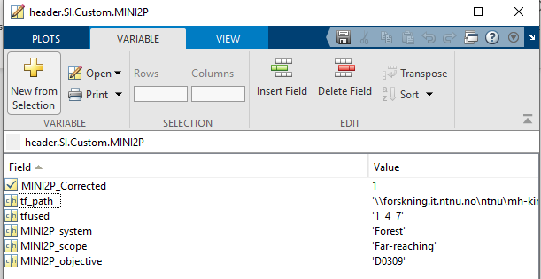

*Readout of custom MIN2P information from the SI tiff header of corrected data.*

5 Transformation matrix related information

i) Transformation matrix file path

This tells you which transformation matrix file was used to do the correction. This information can be found in two places:

a. MDF.

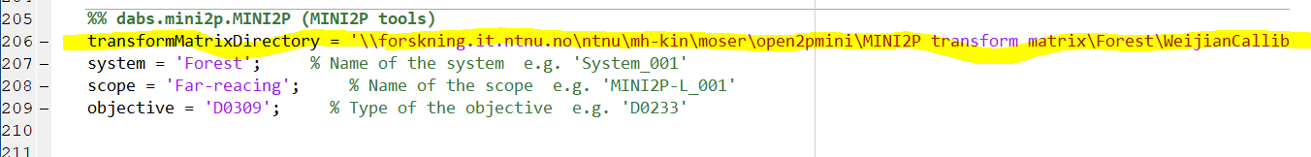

*This figure shows where in MDF you can find the transformation matrix file path*

b. SI tiff header of the corrected the correction data. To access this data, use SI function:

[header, Aout, imgInfo] = scanimage.util. opentif (filename);

Transformation matrix path: header.SI.Custom.MINI2P.tf_path;

ii) Transformation matrix ID used in each data.

This tells you which matrix in the transformation matrix file (cell array) was used to do the correction. It was decided by searching for the matrix that was calibrated in the fast-z position with shortest distance to the fast-z position where the raw date was recorded from. If multiplane imaging was applied, it indicates one number for each plane. The transformation matrix ID is saved in the SI tiff header during correction data generation. To access this information, use SI function:

[header, Aout, imgInfo] = scanimage.util. opentif (filename);

Transformation used for the data: header.SI.Custom. MINI2P.tfused.

*This figure shows the custom information in SI tiff header of one corrected data file (3-plane recording). Here, number 1, 4 and 7 matrixes in the transformation matrix file were used to do the correction for each plane, respectively.*

5 MINI2P related information (MINI2P system name, miniscope name, and the objective type).

This information can be found in three places:

i. Machine data file of SI:

ii. Transformation matrix saved during “Distortion Detection”;

iii. Tiff header of the distortion corrected image:

[header, Aout, imgInfo] = scanimage.util. opentif (filename);

System name: header.SI.Custom. MINI2P.MINI2P_system.

Scope name: header.SI.Custom. MINI2P.MINI2P_scope.

Objective name: header.SI.Custom. MINI2P.MINI2P_objective.

Note: the field of “Custom” only appear after the distortion correction (not exist in raw data).